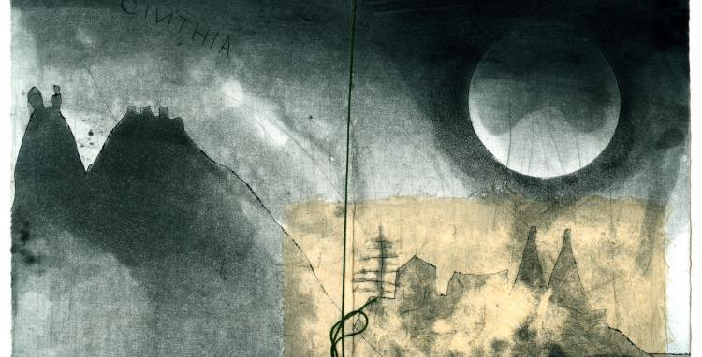
ROMANTICISM AND THE PERIPHERIES: AN INTERNATIONAL AND INTERDISCIPLINARY CONFERENCE
5–7 December 2016, Lisbon, Calouste Gulbenkian Foundation

REGISTRATION FORM

1. Personal Data
Speaker/Attendant’s name:
Affiliation:
Address:
Country:
Phone:
Email:

